C16996_10/ISB – Prototyp HERMES5 SharePoint

Artifacts & Deployment Instructions to Hermes H5 SharePoint 2013 Prototype

Author: Gianni Zanetti, Voltar Systems GmbH ([zanetti@voltar.ch](mailto:zanetti@voltar.ch))

# History of this Document

|  |  |  |
| --- | --- | --- |
| Date | Comment | Author |
| 23.4.2014 | Initial version | Gianni Zanetti |
| 1.6.2014 | Smoke Test and purpose specified | Gianni Zanetti |
| 13.7.2014 | Chapter “Overview of the provided Files” added. | Cornel Studach |
| 15.7.2014 | Document Review Developer | Gianni Zanetti |
| 25.7.2014 | Shutdown Time Limit - adapt in Central Admin Application Pool | Gianni Zanetti |
| 28.7.2014 | Minor corrections | Cornel Studach |
| 28.7.2014 | Step 3 File name corrected | Gianni Zanetti |
| 29.7.2014 | Section “Smoke Tests”: File name corrected | Cornel Studach |

# Purpose of Document

To give precise step by step instructions how to deploy the existing Hermes H5 SharePoint 2013 Pilot platform

Target Audience: SharePoint Administrators., SharePoint Architects with experience in Client-Sided Scripting (CSOM Client Side Object Model

# Overview of the provided Files

1. Project “Vorlagen_WP”

(Vorlagen_WP.sln as Visual Studio Source Content plus Metadata)

1. Project “Rollenzuteilung_WP”

Rollenzuteilung_WP.sln, was Visual Studio Source Content plus Metadata)

1. Project: “HERMES5_Projektvorlage.WSP”

(This is a file in "CAB" format that can be renamed with the extension".CAB" and then can be unzipped using 7-Zip). The WSP file can be directly imported into Visual Studio.

The development environment that can be used to develop and maintain this project is available on <http://collaboration-dev.hermes5-online.ch>. The development was done directly on the web platform. The last version was extracted from there as package.

The Hermes 5 Portal is located on the SharePoint 2013 Server ([collaboration.hermes5-online.ch](http://collaboration.hermes5-online.ch/)) as "Publishing Portal Site" (templating is not supported by Microsoft). An existing portal has to be complemented with the content of the file "Portal-SiteAssets.ZIP” in order to activate Hermes5 Projektvorlage.

As alternative option – if deployed to an environment running on SharePoint Foundation Edition only, there exists the file

1. Project “HERMES5_PROJEKTPORTAL.WSP”

This solution package is used to make a start site using SharePoint Foundation Edition (without SharePoint Enterprise Edition). Projects can be added to the start site as sub-sites.

# Step 1: Web Parts

Install the following two web parts to the target farm (or WebApplication)

File “Vorlagen_WP.WSP”

File “Rollenzuteilung_WP.WSP”

Example:

Add-SPSolution -LiteralPath Vorlagen_WP.WSP

Install-SPSolution -Identity Vorlagen_WP.WSP -GACDeployment

# Step 2: Web Solution Package for Project Portal

File “Hermes5_Projektportal.WSP”

1. Action: Install “Hermes5_Projektportal.WSP” into the solution catalogue of the target farm (gets activated automatically when upload to the solution catalogue)
2. Action: Create a new Site Collection using the given solution “Hermes5_Projektportal.WSP” as the root site

# Step 3: Web Solution Package for Hermes5 Sharepoint 2013

File “HERMES5_Projektvorlage.WSP“

Hint: This file serves as Site Template for the Hermes5 projects.

It contains in the current version the Feature ID {6c0638dc-4211-47ea-a2a4-4cfd52284afe}. This ID is referenced in the below given script to create a new Hermes5 Project Site.

In case the package (HERMES5_projektvorlage.wsp) is updated then any new feature ID of the solution would need to be applied in the JS-Script.

Action: Install this file into the solution catalogue of the project portal (gets activated automatically when upload to the solution catalogue)

# Smoke Tests: Hermes5 Project Template

To test the installation, add manually a new sub-site, using the “HERMES5_Projektvorlage.WSP” as template (shows up in Custom Templates)

Once this new template can be successfully applied to create a new sub-site, inspect the following points to verify successful installation

1. Complete sub-Site is created
2. Document Templates are in place
3. Role List is in place and can be edited
4. Result List is in place and can be edited
5. Task List is in place and can be edited

# Option Publishing Portal Site

Hint: Creating a Publishing Portal Site thru use of a site template is currently not supported by Microsoft. The following steps can be used in such a case

In case you want to use a publishing portals site, as the root of the project, then manually apply the following files and actions

Action: Install the following files into the existing Library “SiteAssets” (File: PORTAL-SITEASSETS.ZIP)

* Hermes5.jpg
* jquery.min
* jquery.SPServices-2013.01.min
* jquery-1.10.2
* spjs-utility.js

Load the following file to your list templates: Hermes5_Projekterstellung.STP –

1. Action: Create a new List called “Projekterstellung“ from the List template Hermes5_Projekterstellung.STP
2. Action: add a scripted link to create a new project item in this list in the top or quick URLs (example: /_layouts/15/listform.aspx?PageType=8&amp;ListId=%7BF3E6FDE8%2D23F4%2D4AD8%2D8F06%2DC51B3FEF4CC5%7D&amp;RootFolder=&source=https://collaboration.hermes5-online.ch) –   
   Action: Replace in the given URL the ListID with the GUID of your current implementation and the source with the URL of your root site.
3. Add /edit a script webpart in the page Lists/Projekterstellung/EditForm.aspx with the following code below

<script src="../../siteassets/jquery.min.js"></script>

<script>

// Blank team Site: var ProjectTemplateGUID = 'STS#0';

var ProjectTemplateGUID = '{6c0638dc-4211-47ea-a2a4-4cfd52284afe}#HERMES5_Projektvorlage';

var Projektname;

var Projektname;

var Firma; // left variable, label changed to Amt

var Abteilung;

var Auftraggeber;

var Projektleiter;

var Projektlink;

var Projektbeschreibung;

var Projektpfad;

var waitDialog='' ;

var notifyID='';

var NewWebURL;

$ (function(){

Projektbeschreibung = $("input[title='Projektbeschreibung']").val();

Projektname = $("input[title='Projektname']").val();

Projektpfad = $("input[title='Projektname']").val(); // Projektname ist jetzt eindeutig erfasst UNIKAT, deshalb Projektname = Pfad

Projektleiter = $("input[title='Projektleiter']").val();

Firma = $("input[title='Amt']").val();

Abteilung = $("input[title='Abteilung']").val();

Auftraggeber = $("input[title='Auftraggeber']").val();

Projektbeschreibung = $("input[title='Projektbeschreibung']").val();

});

SP.SOD.executeFunc('sp.js', 'SP.ClientContext', sharePointReady); // make sure sp.js is loaded

// Create an instance of the current context.

function sharePointReady() {

clientContext = SP.ClientContext.get_current();

website = clientContext.get_web();

clientContext.load(website);

clientContext.executeQueryAsync(onRequestSucceeded, onRequestFailed);

}

function onRequestSucceeded() {

//alert(website.get_url());

}

function onRequestFailed(sender, args) {

alert('Fehler bei der Verbindung zum Server : ' + args.get_message());

}

function onQuerySucceeded(sender, args) {

waitDialog.close();

//alert('Die Projektsite wurde erstellt: ' + this.oNewWebsite.get_title() + ' Decription: ' + this.oNewWebsite.get_description());

// go directly to the new site

NewWebURL= location.protocol +'//'+ location.hostname + '/' + Projektpfad;

// alert('die neue Site ist auf ' + NewWebURL);

// location.href=NewWebURL+ '/lists/Rollenzuteilung';

createProjectData();

}

function onQueryFailed(sender, args) {

waitDialog.close();

alert('Site konnte nicht erstellt werden ' + args.get_message() + '\n' + args.get_stackTrace());

}

function createWebSite() {

waitDialog = SP.UI.ModalDialog.showWaitScreenWithNoClose('Ihr Projekt wird erstellt', 'Wir bereiten die Daten auf, die geschätzte Zeitdauer beträgt rund drei Minuten ...', 180, 480);

var webDescription = Projektbeschreibung;

var webLanguage = 1031;

var webTitle = Projektname;

var webUrl = Projektpfad;

var webPermissions = true; // inherit Permissions

var webTemplate =ProjectTemplateGUID;

clientContext = SP.ClientContext.get_current();

clientContext.set_requestTimeout(300000); // set to 5 minutes to have some reserve 180 seconds is default, not enough

this.oWebsite = clientContext.get_web();

var webCreateInfo = new SP.WebCreationInformation();

webCreateInfo.set_description(webDescription);

webCreateInfo.set_language(webLanguage);

webCreateInfo.set_title(webTitle);

webCreateInfo.set_url(webUrl);

webCreateInfo.set_useSamePermissionsAsParentSite(webPermissions);

webCreateInfo.set_webTemplate(webTemplate);

this.oNewWebsite = this.oWebsite.get_webs().add(webCreateInfo);

clientContext.load(this.oNewWebsite);

clientContext.executeQueryAsync(Function.createDelegate(this, this.onQuerySucceeded), Function.createDelegate(this, this.onQueryFailed));

}

//SP.SOD.executeFunc('core.js', 'SP.ClientContext', createWebSite);/* in some contextes possibly required .... */

function createProjectData() {

//alert('starting createProjectData at ' + NewWebURL);

var clientContext = new SP.ClientContext(NewWebURL);

//alert('newContext loaded ');

var oList = clientContext.get_web().get_lists().getByTitle('Projektdaten');

var itemCreateInfo = new SP.ListItemCreationInformation();

this.oListItem = oList.addItem(itemCreateInfo);

// use internal names

oListItem.set_item('Title', Projektname);

oListItem.set_item('Company', Firma);

oListItem.set_item('ol_Department', Abteilung);

oListItem.set_item('Auftraggeber', Auftraggeber);

oListItem.set_item('Projektleiter', Projektleiter);

oListItem.set_item('Projektbeschreibung', Projektbeschreibung);

oListItem.set_item('Web_x0020_Link', NewWebURL);

oListItem.update();

//alert('Update done');

clientContext.load(oListItem);

clientContext.executeQueryAsync(Function.createDelegate(this, this.oncreateProjectDataSucceeded), Function.createDelegate(this, this.oncreateProjectDataFailed));

}

function oncreateProjectDataSucceeded() {

// change the display names as needed

//changeDisplayName();

// redirect to new site

var targetPage = NewWebURL + '/lists/Projektdaten';

NewItem2(event, targetPage);

}

function oncreateProjectDataFailed(sender, args) {

alert('Projekt-Eintrag konnte nicht erstellt werden. ' + args.get_message() + '\n' + args.get_stackTrace());

}

function changeDisplayName() {

/* Adapting the Display Names*/

var ctx = new SP.ClientContext(NewWebURL);

field = ctx.get_web() //SP.Web

.get_lists() //SP.ListCollection

.getByTitle('Aufgaben') //SP.List

.get_fields() //SP.FieldCollection

.getByInternalNameOrTitle("Title"); //SP.Field

ctx.load(field, "Title"); //load only Title

ctx.executeQueryAsync(function() {

field.set_title("Aufgabe");

field.update();

ctx.executeQueryAsync();

});

field2 = ctx.get_web() //SP.Web

.get_lists() //SP.ListCollection

.getByTitle('Ergebnisse') //SP.List

.get_fields() //SP.FieldCollection

.getByInternalNameOrTitle("Title"); //SP.Field

ctx.load(field2, "Title"); //load only Title

ctx.executeQueryAsync(function() {

field2.set_title("Ergebnis");

field2.update();

ctx.executeQueryAsync();

});

}

</script>

<input id="btnNewDocument" onclick="javascript:createWebSite();" type="button" value="Website für dieses Projekt anlegen"/>

# Smoke Tests after installation of Script

A new project can be created from the list “Projekterstellung“using the script button (Button with the description “*Website für dieses Projekt anlegen*”)

# Shutdown Time Limit - adapt in Central Admin Application Pool

Depending on Server Capacity, resource challenging and general infrastructure (SharePoint Farm) it becomes a necessity to adapt in CENTRAL ADMIN the time out level. (Shutdown Time Limit). This increase is required, should you receive a time out message while creating the project site.

To change it , open IIS MANAGER – APPLICATION POOLS – SHAREPOINT CENTRAL ADMINISTRATION POOL – ADVANCED SETTINGS. Currently on IOZ environment it is set to 900 seconds, with a modern Quad-Core Processor it might be set to 240 seconds and still have sufficient reserves.

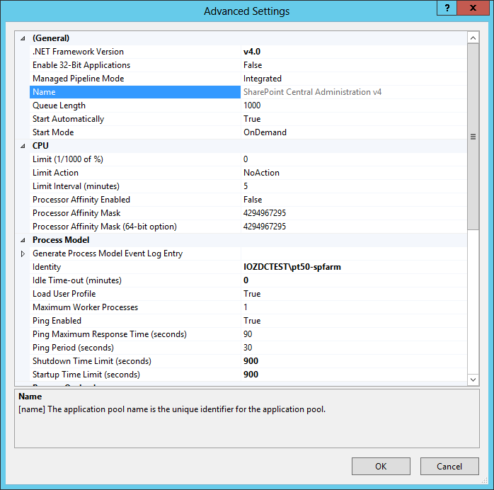

Reference: http://njbblog.blogspot.ch/2014/02/sharepoint-2013-how-to-increase.html